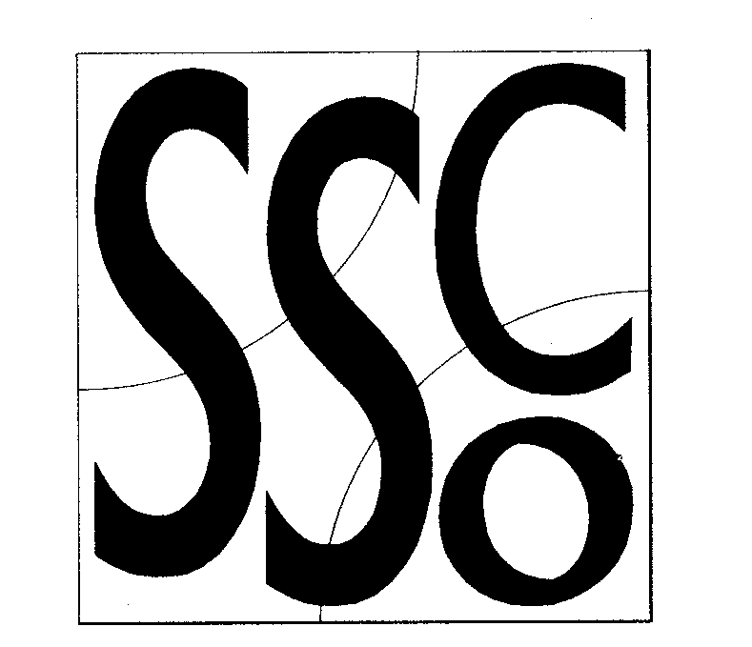

Teaching Points
‘Bowl’ like shape with hands to catch.
Keep emphasis on catching & not tricks.
Keep eyes on the object.
.Throw with 1 hand.

Throwing & Catching 1
MULTI SKILL CARDS



Classification
Throwing and catching on own.
Hand eye co-ordination.

Equipment
Tennis balls, bean bags, quoits, large balls, small balls.

Differentiation
Harder: Use smaller objects Encourage harder tricks.

Easier: Use larger objects

Activity/ Key Points

- Pupil rolls object across the floor and retrieves and repeats.

- Pupil throws object in the air and attempts to catch in any way possible. Encourage pupils to catch with 2 hands making a bowl shape.

- Once pupil can catch the object the majority of times encourage them to throw the object higher.

- Can the pupil throw the object in the air and clap their hands before they catch it?

- As they improve increase the number of claps before they catch.

- Can the pupil make up their own trick before catching e.g. clap under leg, touch their head, spin round in complete circle.

- Let the ball bounce on the floor before catching.

- Introduce the clapping and tricks whilst the ball is bouncing.

- Repeat with reaction balls.

